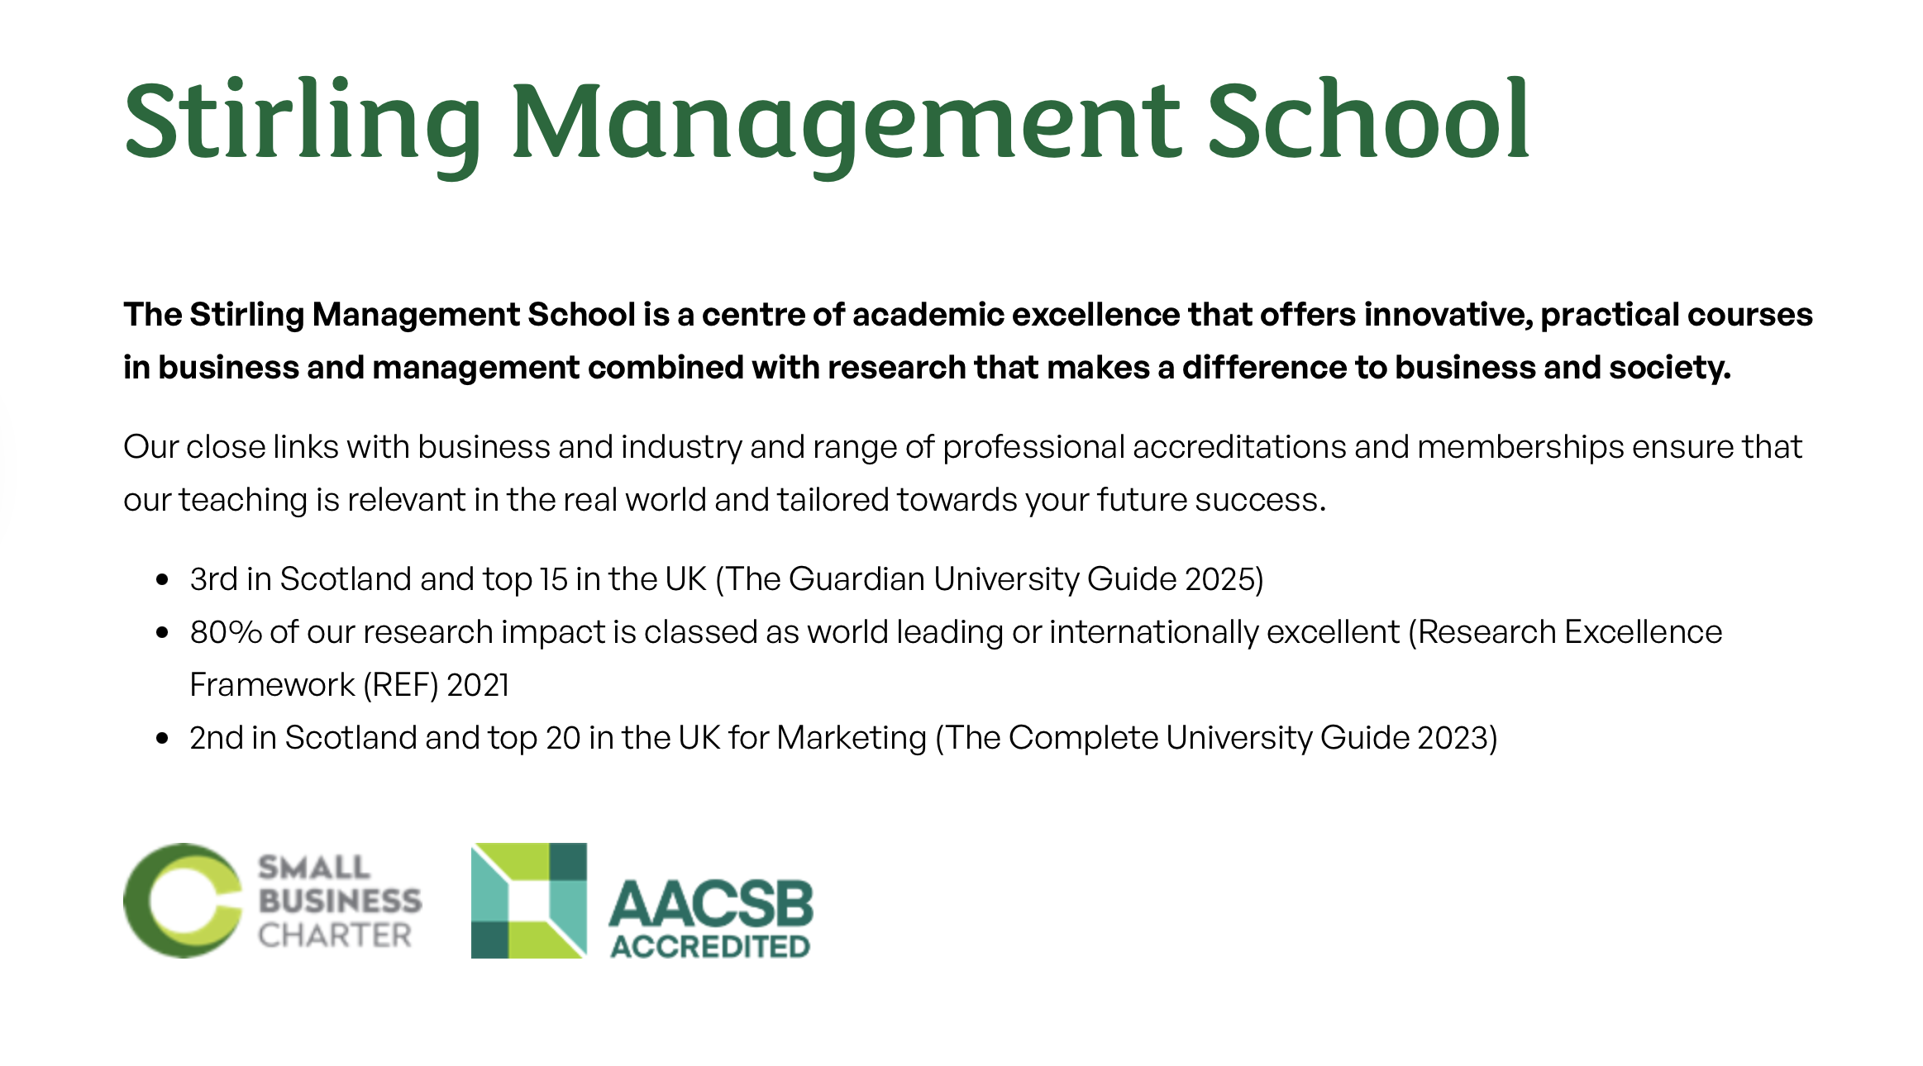

BBA Programme

With almost 8,000 students, 200 faculty members, and XXX administrative personnel, the Bachelor of Business Administration at the School of Business and Economics is the largest academic degree programme in Bangladesh, offering students an unparalleled learning experience.



We maintain the highest number of industry collaborations and international accreditations, reflecting our commitment to industry-focused education. Our BBA is benchmarked against global and the Government of Bangladesh standards.
We proudly hold the 1st position among all universities in Bangladesh in both Times Higher Education and QS World University Rankings.

Our accreditation and recognitions include:
- ACBSP (Accreditation Council for Business Schools and Programs) — Accredited since 2014
- CABS (Chartered Association of Business Schools) — Accredited since XXX.
- SAQS (South Asian Quality Systems) — Member since 2018
- AACSB (Association to Advance Collegiate Schools of Business) — Member since XXX
- Approved by the UGC (University Grants Commission) of Bangladesh
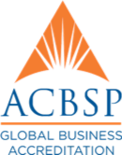

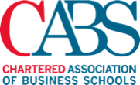



Students’ photo Lab/innovation photo
Our mission is to produce responsible global citizens, equipped with ethical values and international competencies, who are committed to driving meaningful change for people and society.
Our vision is to become the leading regional hub of business knowledge for the betterment of society.

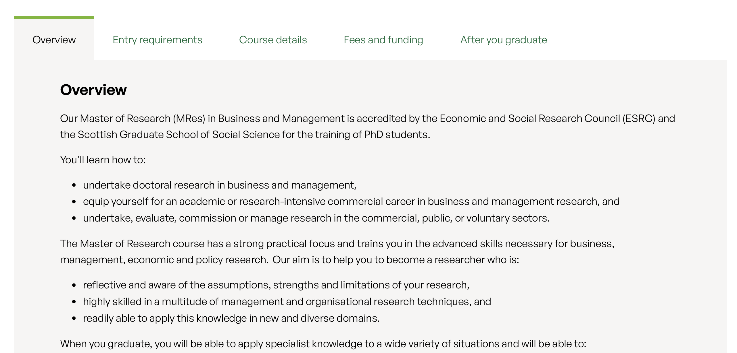
A Warm Welcome from the Director

Photo

Dear Prospective Students,

You are about to make an exciting and important decision about what and where to study, and we are here to support you in making an informed and confident choice.

I am delighted to introduce the Bachelor of Business Administration (BBA) Programme at North South University (NSU)—an exceptional platform for enhancing your knowledge and sharpening the skills required to thrive in today’s global business landscape. The BBA is one of the most versatile undergraduate degrees, broadening your horizons and unlocking international opportunities.

Our internationally recognised BBA programme is not only the top-ranked but also the largest in the country, accredited by leading industry bodies in recognition of our excellence in business education. We offer a modern, industry-focused Outcome-Based Education (OBE) curriculum within an inclusive and supportive environment, where students are encouraged to question, exchange ideas, express opinions, think critically, and embrace diverse perspectives. Our distinguished faculty members, with global academic and professional experience, instil ethical values and prepare students for the realities of life and career.

We are committed to helping our students maximise their career potential. In addition to interactive classroom learning, we offer a wide range of enriching experiences beyond the classroom, including student exchange programmes abroad, collaborative research, industry visits, training sessions, workshops, business competitions, networking and career events, club and volunteering engagements, and many skill development programmes. These extensive co-curricular and extra-curricular opportunities help our students build essential skills that distinguish them in the job market. We are proud of our strong alumni network, with our graduates excelling across public and private sector organisations worldwide. Our graduates leave with more than a degree—they gain the credentials and confidence for lifetime employability.

I warmly invite you to embark on a transformative and globally attuned learning journey through our BBA, fostering both personal and professional growth. We encourage you to visit our vibrant campus and explore our website to learn more.

Wishing you every success in your journey ahead.

Dr Muhammad Faisol Chowdhury
Associate Professor & Director, BBA Programme

———

Overview
The NSU BBA is a four-year undergraduate degree approved by the University Grants Commission (UGC) of Bangladesh, comprising twelve academic terms within a trimester system (Spring, Summer, and Fall). The programme aims to equip students with the qualifications and skills necessary to succeed as entrepreneurs or business professionals.

Programme Learning Objectives
Through our BBA, you will learn how to:
  - Communicate ideas and present arguments effectively in both business and social contexts;
  - Think critically and analytically;
  - Uphold ethical standards and promote sustainability in business practices;
  - Apply theoretical knowledge and technological skills to decision-making across key business areas, including accounting, finance, human resources, marketing, management, supply chain, management information systems, and business analytics.

BBA Credit Requirements
You are required to complete 130 credits to earn your BBA degree. The programme follows an open credit system, allowing students to enrol in a minimum of two courses (6 credits) and a maximum of five courses (15 credits) per academic term. You may complete your degree with 127 or 124 credits, depending on whether ENG102 and/or BUS112 were waived at the time of your admission. If neither of these courses was waived, the graduation requirement remains 130 credits.

Dual Concentration/Major
You may complete your BBA with double concentrations/majors by taking an additional three courses / 9 extra credits.
Credit requirements for single concentration/major
Course Segments | Number of Courses | Credits
School Core Courses | 7 | 21
BBA Core Courses | 12 | 36
General Education (GED) Courses | 12 | 36
Concentration/Major Courses | 6 | 18
Free Elective Courses | 3 | 9
Internship | 1 | 4
Total  If ENG102 and/or BUS112 is waived | 41 | 124
Total  If ENG102 and/or BUS112 is not waived | (41 + 1 +1) | 127 or 130

Credit requirements for dual concentration/major
Course Segments | Number of Courses | Credits
School Core Courses | 7 | 21
BBA Core Courses | 12 | 36
General Education (GED) Courses | 12 | 36
Concentration/Major 1 Courses | 6 | 18
Concentration/Major 2 Courses | 6 | 18
Internship | 1 | 4
Total  If ENG102 and/or BUS112 is waived | 44 | 133
Total  If ENG102 and/or BUS112 is not waived | (44 + 1 +1) | 136 or 139

Concentration/Major Areas
Students may choose one of two concentration/major areas from the following nine options:
  - Accounting (ACT)
  - Economics (ECO)
  - Finance (FIN)
  - Human Resource Management (HRM)
  - International Business (INB)
  - Management (MGT)
  - Management Information Systems (MIS)
  - Marketing (MKT)
  - Supply Chain Management (SCM)

BBA Graduation CGPA Requirements
To be eligible for graduation, you must maintain the following academic standing:
  - A minimum CGPA of 2.0 on a 4.0 scale.
  - A minimum GPA of 2.0 in both the School Core and BBA Core areas.
  - A minimum GPA of 2.5 in the concentration/major area.

If your CGPA falls below 2.0 in any term, you will be placed on academic probation. Students who remain on probation for three consecutive terms will be subjected to academic dismissal.

Course Waiver Policy
Please check the ‘Entry Requirements’ section to know about the ENG102 and BUS112 waiver policy.

———

Programme Details
Please download the BBA Course Handbook from:
https://drive.google.com/file/d/1ZnnyLk0k6cFRIMjJutuL01Vx-dqMtkzG/view

The Course Handbook contains comprehensive details of all courses and serves as an excellent source of essential information regarding the curriculum.

Add Course Map and Path photos here.
———

Entry Requirements
Bangladeshi Applicants
Applicants must meet one of the following academic qualifications:
  - SSC and HSC: A combined GPA of 8.0 (on a 5.0 scale) with a minimum GPA of 3.5 in each examination.
Or
  - GCE O-Levels and A-Levels: A minimum of five O-Level subjects with an average grade point of 2.5, and two A-Level subjects with an average grade point of 2.0. Only one grade of ‘E’ is acceptable across the combined O- and A-Level results. (Grading scale: A = 5, B = 4, C = 3, D = 2, E = 1)
Or
  - International Baccalaureate Diploma Programme (IB-DP): Completion of six subjects with a minimum average grade point of 4.0 out of 7.0, equivalent to a total of 24 points.
Or
  - US High School Diploma: A minimum score of 60%.

Applicants whose academic credentials differ from the categories listed above must obtain an equivalence certificate from the appropriate Education Board. Please note that Foundation and/or GED programmes are not recognised for BBA admission at NSU.

Prospective students with alternative academic qualifications are advised to contact the Admissions Office to determine their eligibility.

International Applicants
International applicants must have completed 12 years of schooling with a minimum average mark of 60%, and must meet one of the following English language proficiency criteria:
  - The medium of instruction in previous studies was English.
Or
  - One of the following minimum scores in recognised tests:
    - SAT: 1100 (on a 1600 scale)
    - IELTS: Overall band score of 6.0
    - TOEFL:
          - Paper-Based Test (PBT): 514
          - Computer-Based Test (CBT): 180
          - Internet-Based Test (iBT): 72

All academic documents of international applicants must be verified by the Ministry of Education or the relevant Embassy.

Course Waiver Policy
Students may be eligible for course waivers based on standardised test scores, as outlined below:
Test | Minimum Required Score | Courses Eligible for Waiver
SAT (1600 scale) | 1150 | ENG102 and BUS112
IELTS | 7.0 | ENG102
TOEFL | PBT 563 / CBT 223 / iBT 85 | ENG102

Course Waiver Application Procedure
Candidates who meet the above criteria must follow the procedure below to apply for course waivers:
  - Send an email to the Director, Office of Admission at: admissions@northsouth.edu
The email must include:
        - The NSU Test Pass Number or a copy of the NSU Admit Card
        - A scanned copy of the official SAT / IELTS / TOEFL certificate
  - Candidates must verify their documents through the respective online verification portals. A user ID and password may be required for this process.
  - Please note:
      - Course waiver requests must be made at the time of document verification.
      - Original official certificates must be submitted at that stage.
      - Requests submitted after document verification will not be considered.

Admissions Office
Find out more on the Admissions Webpage:
https://admissions.northsouth.edu/undergraduate_requirement

Or visit the Admissions Office located on the 3rd floor of the Admin Building.

Tel: (+8802) 5566 8200, Ext. 4001, 6299
Mobile: (+88) 017 3290 3003
Email: admissions@northsouth.edu

———

Fees & Financial Aid
The cost of tuition ranges from BDT 9,25,000/- to BDT 10,25,000/- depending on your course waiver status at the time of admission. All fees are subject to change. Please consult the Admissions Office for the most up-to-date fee structure. An approximate fee breakdown is provided below.

Fees Category | Amount in BDT
Admission Fee (one time) | 25,000
Caution Money (one time) | 10,000
RFID Card (one time) | 1,000
Tuition Fee (per credit) | 6,500
Student Activity Fee (per term) | 3,000
Computer Lab Fee (per term) | 2,500
Library Fee (per term) | 1,500

NSU offers a range of scholarships and financial aid to deserving students. Please visit the Financial Aid Office webpage for further details: https://www.northsouth.edu/resources/fao.html

———

BBA Help Desk
The BBA Help Desk is located on the 6th floor of the NAC building, within the School of Business and Economics. Our dedicated officers are available to provide you with a wide range of academic and administrative services.

Academic Support:
  - Term/trimester drop procedures
  - Credit transfer processing
  - Department change procedures
  - Course inclusion and exclusion in RDS
  - Degree analysis and verification through RDS
  - Information and guidance regarding academic probation
  - Coordination of regular and probation advising
  - Consultation on course curriculum and course mapping

Administrative Support:
  - Coordination of the BBA curriculum
  - Facilitation of freshman advising each term
  - Issuance of testimonials and reference letters
  - Programme documentation and record-keeping
  - Appointments with students’ parents/guardians and necessary follow-ups
  - Resolution of other course- and curriculum-related matters

———

After You Graduate
BBA is one of the most versatile degrees in the world. The NSU BBA is ideally suited for those seeking to pursue a professional career in business. It is equally invaluable for aspiring entrepreneurs who wish to develop a strong foundation in business principles and practices.

Our BBA is widely recognised by international universities and accepted as a valid entry qualification for Master’s, MBA, and other postgraduate programmes abroad.

Feel free to consult the Director of the BBA Programme for guidance on career planning and professional development.

———

